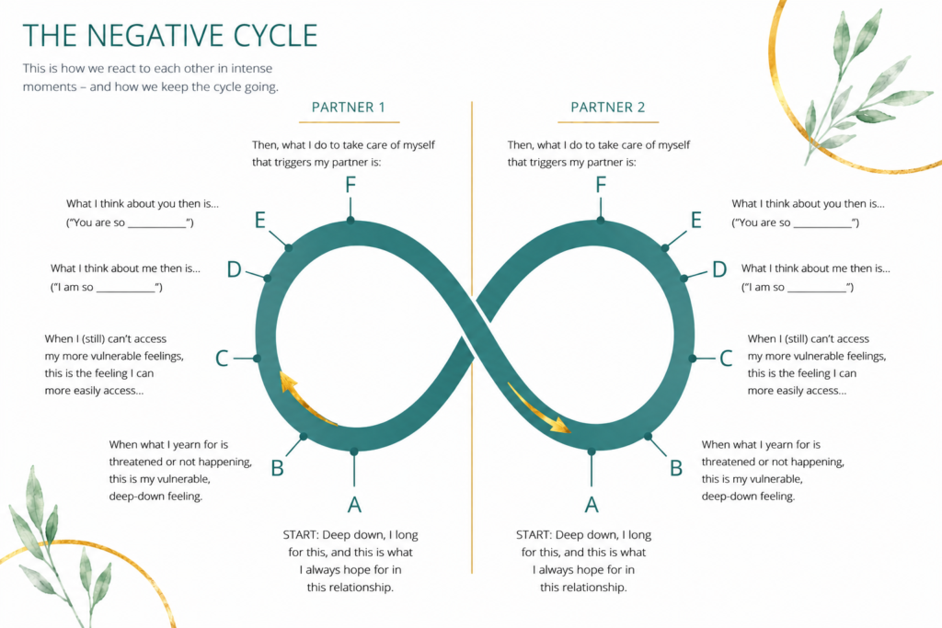
Before you start
It's a good starting point to use one concrete, recent situation that is rather typical in your relationship. Don't worry about getting it exactly right or representative. You can keep coming back to this after a disagreement and explore again together: what actually happened there?
Start gently. You do not have to reach the deepest layer immediately. Sometimes “I don’t know yet, but I notice tension” is already a perfectly good beginning.
Fill in your own side first. Then look together at how one side affects the other.
If there is violence, threat, coercion, serious addiction, or active unsafety, do not do this exercise together at home. This belongs in a safe therapeutic setting.

The six layers of the cycle
Letter | Layer | What you explore | Sentence starter
A | Deep longing / attachment need | What do you deeply want to feel in this relationship?  E.g. Loved, important, chosen, safe, free, close, understood, welcome. | “I long to feel ... with you.”
B | Vulnerable primary feelings | What do you feel underneath the surface when that longing is touched or seems unavailable?  E.g. alone, scared, small, not chosen, sad, powerless, ashamed, rejected, unimportant, empty, lost, unwelcome | “Underneath my anger/distance/annoyance, I feel ...”
C | Reactive or protective feelings | What comes on top of the vulnerable feeling?  This is often what your partner sees first: e.g. anger, irritation coldness, control, panic, shame, hardness, controlling, pure logic. | “What you usually see is that I become ...”
D | Thoughts about myself | What do you start telling yourself?  Often painful conclusions: I am too much, not important, alone, difficult, powerless, rejected. | “In that moment, I think about myself: I am so ...”
E | Thoughts about my partner | What do you start thinking about your partner?  E.g. You don’t see me, you don’t care, you attack me, you always withdraw, you’re never satisfied. | “In that moment, I think about you: you are so ...”
F | Protective actions / outside behaviour | What do you do to protect yourself?  E.g. Push, explain, go silent, withdraw, please, control, criticize, text, joke, leave, shut down. | “What I do to protect myself is ...”
Worksheet for partners
Layer | Partner 1 | Partner 2
A — Longing
I long to feel ... with you.

B — Vulnerable feeling
When that does not seem to happen, deep down I feel ...

C — Reactive feeling
What you usually see or hear is ...

D — Thoughts about myself
Then I think about myself: I am so ...
E — Thoughts about you
Then I think about you: you are so ...
F — Protective action
What I do to protect myself is ...
How to talk about this together
Read your own A and B first, before moving to C–F. The softer layers often make it easier for your partner to listen.
After one partner shares, the listening partner first reflects what they heard. Try to really take in what your partner is saying.
Then look together for the cycle sentence:
“The more I ..., the more you ..., and then I feel ..., which makes me ... even more.”
Examples:
“The more I push, the more you shut down; and the more you shut down, the more alone I feel, so I push harder.”
“The more I go quiet, the more anxious you become; and the more anxious you become, the more I feel I’m failing, so I go even quieter.”
Once you identified the loop, it helps to give it a name. The next time you're caught in a fight, naming it helps taming it.

